The Respicy Index

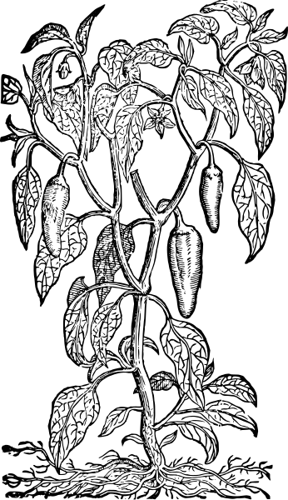

Concept Document

Team #1

James McGuigan

Steven Forester

SUNY College at Old Westbury

# **Table of Contents:**

**Table of Contents: 2**

**Problem Statement 3**

Our Goals: 4

**Mission Statement 4**

**Project description 5**

Proposal: 5

Overview: 5

**Use Cases 8**

Use Case 1: Welcome Page 8

Use Case 2: Account Registration/Login 9

Use Case 3: Profile Management 10

Use Case 4: Recipes 11

Use Case 6: Home Page 12

Search Engine Class Diagram 13

Use Case 9: Data Management 14

Use Case 10: Planners and Guides 15

Flow Case 11: Feedback, Contact, and Support 16

Use Case 12: Admin Page and Controls 17

**Flow of Events Diagrams 18**

Flow 1: Landing, Registration, Sign-in, Sign-Up, Footer 18

Flow 2: Homepage, Header, Navigation, Profile 19

Activity: 20

**Appendix 21**

Key Terms: 21

References: 21

ADDITIONAL IDEAS 22

# 

Jimmy’s edits

* Ticketing gos to email
* Created recipe process
* create>keyword filter>if clean>publish>else >Send to modtable+ send email stating recipe is awaiting moderation
* Admin link to ticket email

# Problem Statement

The Purpose of this project is to create a platform for ease of use service to the end user toward ….

<The problem statement, which defines an issue and how it is affecting the

organization.>

* Example1: The average customer service on-hold time for XYZ company exceeds five minutes during both its busy and slow seasons.
* Example2: Leaders at XYZ company want to increase net revenue for its premium product line of widgets by 5% for the next fiscal year.
* Example3: In the last three quarterly employee engagement surveys, less than 30% of employees at the XYZ company stated that they feel valued by the company. This represents a 20% decline compared to the same period in the year prior.

In developing a problem statement, it helps to think like a journalist by focusing on the five Ws: who, what, when, where, and why or how. Keep in mind that every statement may not explicitly include each component. But asking these questions is a good way to make sure you’re covering

the key elements:

• Who: Who are the stakeholders that are affected by the problem?

• What: What is the current state, desired state, or unmet need?

• When: When is the issue occurring or what is the time frame involved?

• Where: Where is the problem occurring? For example, is it in a specific department,

location, or region?

• Why: Why is this important or worth solving? How is the problem impacting your

customers, employees, other stakeholders, or the organization? What is the magnitude of

the problem? How large is the gap between the current and desired state?

## Our Goals:

The goal of this project is to outperform competitors in the same or similar industry to develop a better managed, easier to use functional recipe index for end users…..

# Mission Statement

The ReSpicy index is a recipe web system intended for convenience to the end user both utilizing simplicity and well managed structures to develop a system convenient for ……

<The mission/goal statement, which should be in line with the problem you seek to solve, and which should be SMART – specific measurable, attainable, relevant and time-bound.>

Example1: “To enrich people’s lives with programs and services that inform, educate and entertain.”

Example2: “To build the Web’s most convenient, secure, cost-effective payment solution.”

Example3: “To give people the power to share and make the world more open and connected.”

# Project description

A web-accessed database to both explore and add new and creative recipes with features to create meal plans, upload x,y,z, favorite and rate recipes currently available or not…..

<Describe the background and context for the project.>

<Project Name>

Concept Document (v1.0) Page 3 of 6

[Insert appropriate disclaimer(s)]

## Proposal:

The system is designed to use simplistic means to create a dynamic presence for engagement with the user.

## Overview:

We are building a website that will include a landing page, sign-in, and sign-up functionality. The site will allow users to sign in using Google as an alternative to directly signing up with us. Users will have a profile that they can edit by uploading an image, changing their email, bio, and first and last name. An edit profile page will save changes, and a separate profile page will display this information.

The profile page will show user information, created recipe posts, favorite recipes, and ratings (out of 5 stars) given to recipes within the database. Each profile will follow this structure. Users can create recipes and save them to the database, either publicly or privately. Private recipes will be posted to the user's profile and only visible to them.A sign-out feature will return users to the landing page.

The main page will have a navigation bar present on every page except the landing page, featuring:

- Home

- Top 10 recipes

- Meal planner guide and setup

- Recipe index (categorized by ingredients like chicken, pasta, beef, fish, etc.)

- Random recipe generator

- Full recipe database list

The main page will display cards with the top 5 recipes and a horizontal scroll featuring 20 random recipe cards. The footer will include links to the landing page, contact, support, FAQ, feedback, copyright information, and an admin login. Admin users will access a specific login page leading to an admin dashboard with features to monitor, edit, track, and assist website users.

Admins will have full versatility to edit, change, and support as needed. A dynamic view recipe page will display database-saved information for images, titles, ingredients, recipes, measurements, instructions, and notes. It will include copy, save, rate, favorite, and print features. A dynamic search function will be accessible from the main page, navigation bar pages, and view page. The website will aim for simplistic searches and provide suggested recipes based on user data and frequently viewed recipe genres.

1. Landing Page
2. User accounts
   1. Sign in
   2. Sign up
   3. Include google account login functionality
   4. Account
      1. Profile
      2. Edit profile
      3. Create recipe (accessibility toggle)
      4. Edit Recipe
      5. Sign out > return to landing
   5. Admin Page
3. Key Features
   1. Title Bar
   2. Navi Bar
   3. Search Bar
   4. **Footer Fix to page locked**
      1. About us
      2. FAQ
      3. Support
         1. Feedback
      4. Contact Us
      5. Copyright
      6. T&C
4. Home page
   1. Top 5 today
   2. 12 random recipes
   3. Our recommended (top 10 by rating)
5. Top 10
6. Random
7. Full Index
   1. Alphabetical Hyperlinks that return to view page

Outside API’s

# Use Cases

## Use Case 1: Welcome Page

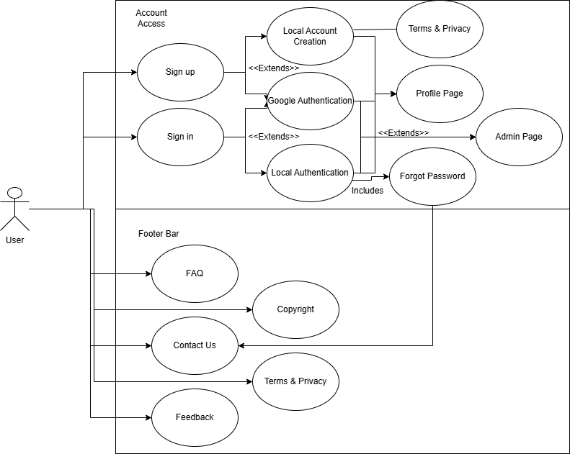

1. Who is going to be using this page?
2. What is the user's reason for accessing the page?
3. What is the purpose of the page?
4. Why is the user here?

## Use Case 2: Account Registration/Login

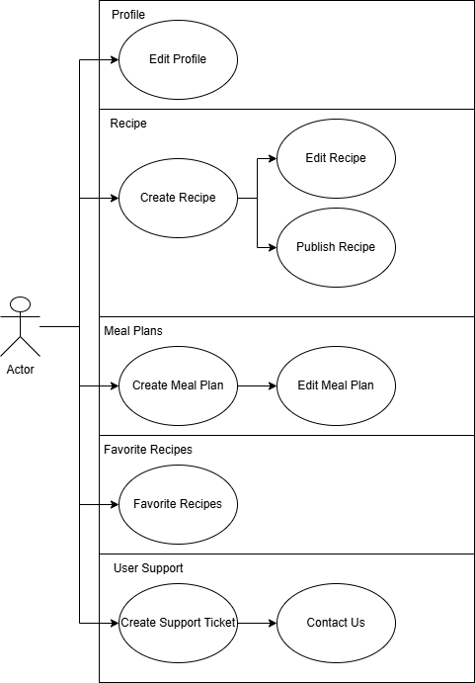

1. What can the user do on this page?
2. What can the admin do on this page?
3. What is the purpose of this page?
4. How are we recording our data?

## Use Case 3: Profile Management

User side Create email change tickets admin side

Edit Password reset

Analytics

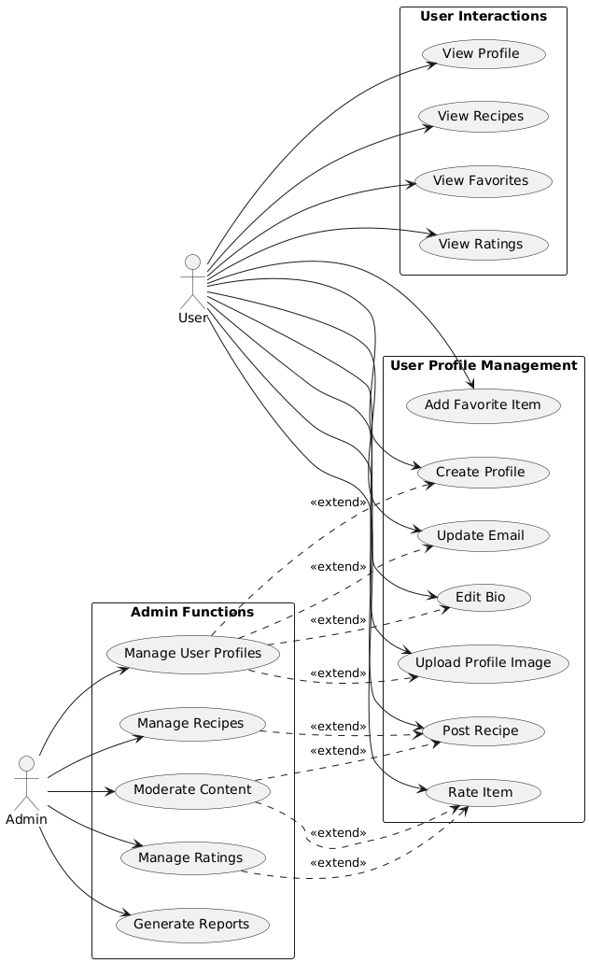

1. How does the user manage their own profile?
2. How can the admin assist the user?
3. What support do we have?
4. What is saved?
5. What can change?

## Use Case 4: Recipes

User Create Editing Admin

Edit Publishing

Moderating

View:

Favorite

Rate

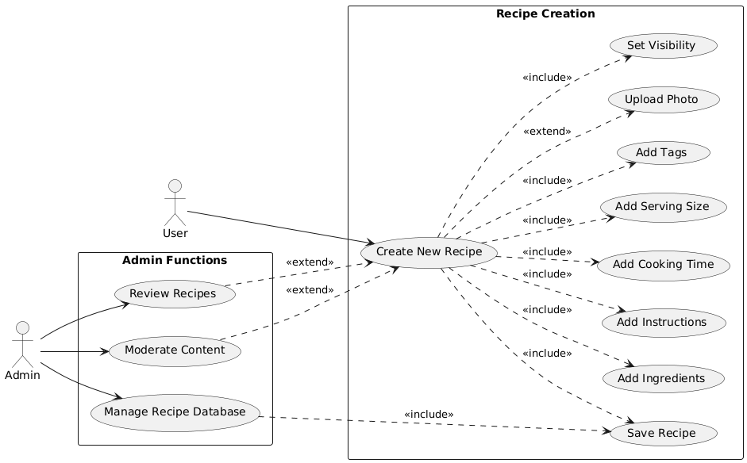

1. Purpose of the view page?
2. What can the user visualize?
3. What can the user do? *Print…*
4. What features will be included? *I.e youtube videos etc…*
5. Why will our page be designed in a specific way? *For print scalability and ease…*

## Use Case 6: Home Page

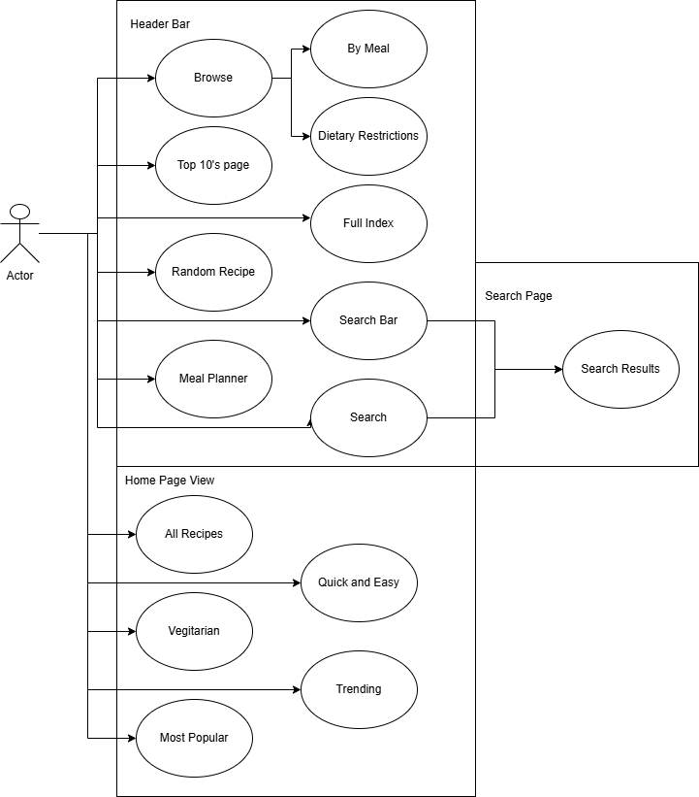

1. What pages will be accessible?
2. What kind of filtering will we have?
3. Why do we have a welcome and a home page?
4. Purpose of the navigation menu?
5. Purpose of the search functionality vs. full index?

## 

## Search Engine Class Diagram

Show filtering system

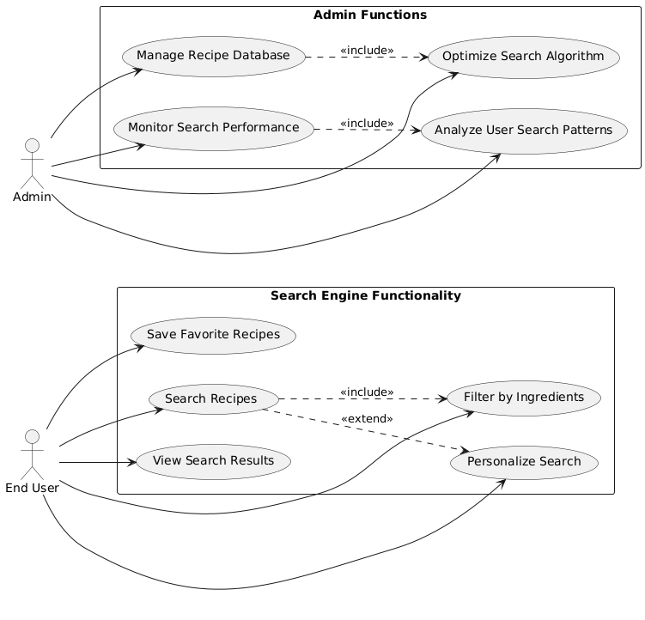

1. What kind of filtering system will we have for searching for recipes?
2. What kind of database will we be interacting with?
3. What is the purpose of this technological stack?
4. How will this be implemented throughout the project?

## Use Case 9: Data Management

User interface -account quarantine edits admin

Edit

-recipes

Edit

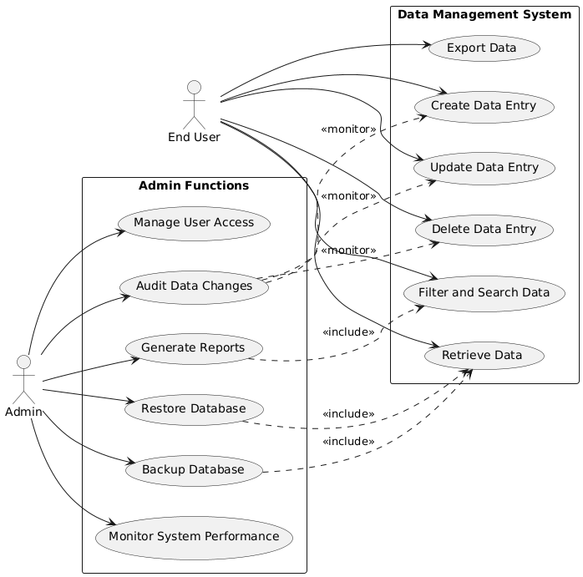

1. What kind of database will we have?
2. How many databases will we have?
3. What is the information that will be CRUD in the database?
4. What will the user have access to?
5. What will the admin have access to?
6. What limit will we have to CRUD?

## Use Case 10: Planners and Guides

User create admin portal api tracker

Edit

-saves to profile

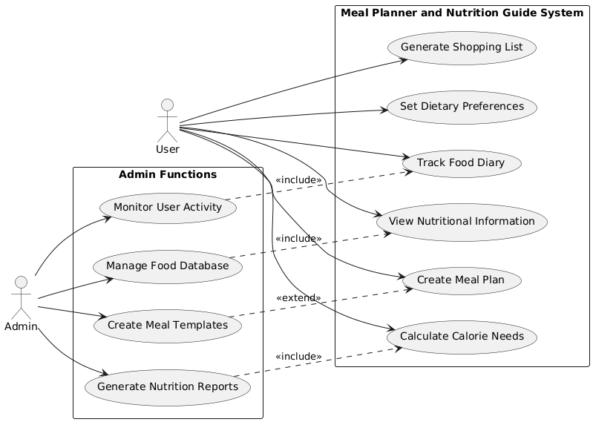

1. How will we fill out the meal planner?
2. How will we regulate our nutrition facts and guide?
3. How will we retrieve our information from the database?
4. How will we record our plan to the user account, profile?
5. What will we include for our plans? *“Active Plan”, “Inactive Plan”, “Delete”*

## 

## Flow Case 11: Feedback, Contact, and Support

User has issue follow process

User has feedback

Admin ticket analytics?

Admin link to ticket email

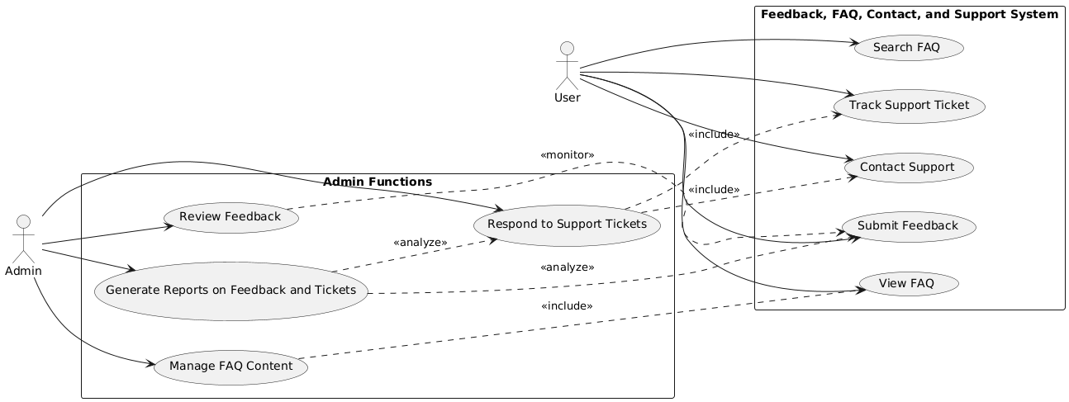

1. What is the purpose of feedback?
2. Why do we give this option to the user?
3. What is our support system for user management?
4. What is our system for data management?
5. How can we CRUD this?
6. How are we Logging the information and using it?
7. What are we using it for? *“Top 10’s”, “Featured Recipes”, “Most Viewed”*

## Use Case 12: Admin Page and Controls

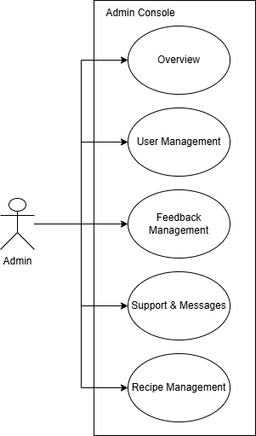

1. What is our admin doing?
2. Why do we need an admin?
3. What capabilities do we have present?
4. What support are we recording?
5. How can the admin assist?
6. How does the admin operate?

# Flow of Events Diagrams

## Flow 1: Landing, Registration, Sign-in, Sign-Up, Footer

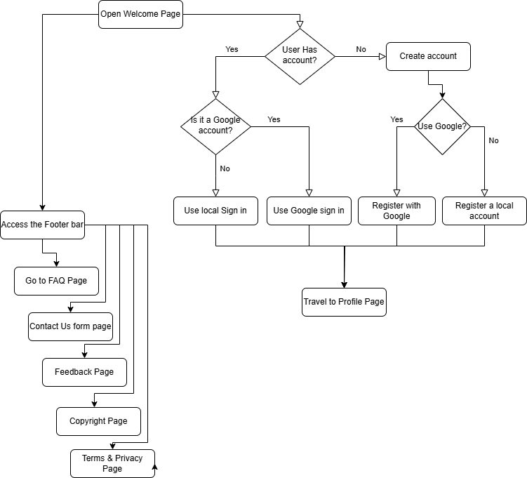

1. How does our Landing page work?
2. How does our registration work?
3. How does our sign-in work?
4. What else can we access without an account?
5. What can we access with an account?

## Flow 2: Homepage, Header, Navigation, Profile

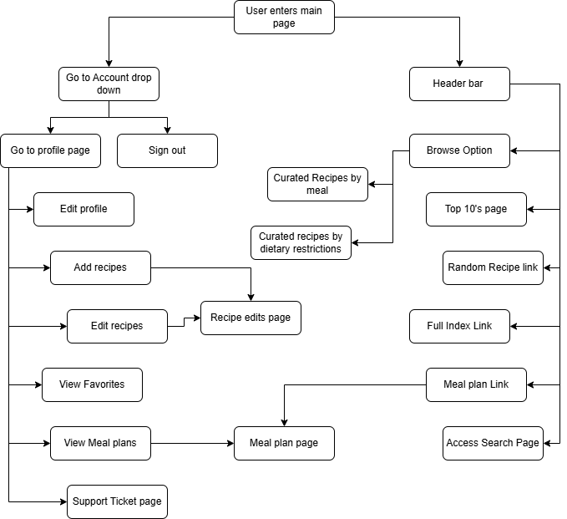

1. After we log-in what capabilities does a user have?
2. What pages are accessible now?
3. What is the purpose of this?
4. Why is our system better than others?
5. Purpose of each of the pages?

## Activity:

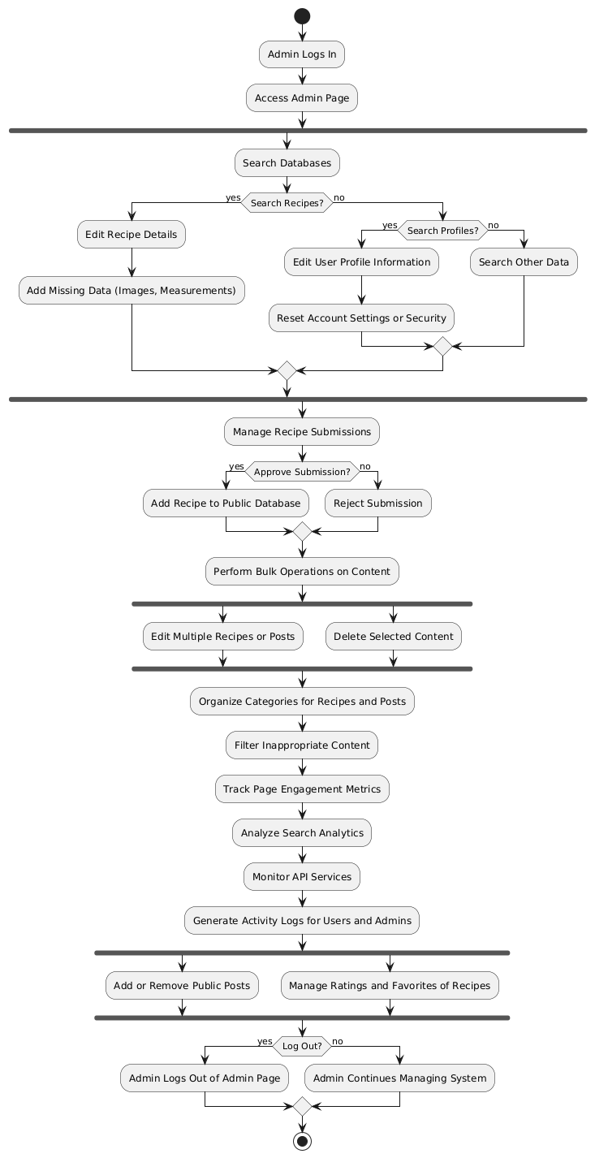

1. How does our system work for an admin?
2. How does our system work for a user?
3. How our support works
4. How does our search work?
5. How does our filtering work?
6. How does our database record information?
7. How do users use our information?
8. How does it get printed?
9. Why is our print page the way it is ?

Class Diagram: Front end overview

1. How is our front end system set up? Tech stack
2. Why did we choose this method?
3. Why is it a web-development system design project?
4. How do we communicate with our back end?

Class Diagram: Back end overview

1. How is our backend system set up? Tech stack
2. Why did we choose this method?
3. Why is our database set up in this regard?
4. How does it work for us? How does it work for the end user?
5. How do we communicate with our front end?

Activity diagram: User entry, admin entry, home page, vie recipes, profile page, create recipe, edit recipe, meal plan,

# Appendix

## Key Terms:

1. What needs to be defined from our Concept document??
2. What key terms are necessary for understanding our system??
3. What is needed for understanding our structures??

## References:

APA format of references or MLA format

### ADDITIONAL IDEAS

